**Lesson plan – Chapter 9 / Types of sentences**

In the last three weeks, we concentrated on creating complex sentences to make your writing style more interesting. We learned about Adjective clauses, Adverb clauses, and Noun clauses.

Look on p. 182 in your textbook. Read the text under *Complex Sentences* and review the three kinds of dependent clauses: adverb clause, adjective clause, and noun clause

Now do Practice 7A on p. 183 – Next to double underlining the dependent clause, also define which one it is (adverb clause, adjective clause, or noun clause). Then do Practice 7B.

Next to combining independent and dependent clauses, combining two independent clauses offers another nice variety to your texts. Remember that this is our main focus! We want to learn how to vary our sentence structure to make our texts clearer, more complex, and more vivid. Read the six lines under *Introduction* on p.171

To prove my point, compare the Writing Models on p.171 and 172. Notice the difference! Find the dependent clauses in the second draft and check the answer key.

Next to these complex sentences, you find two other types of sentences in the text:

* 1. **Simple sentences**

A simple sentence is one independent clause. Textbook p.174: look at the three sentences at the bottom – you notice that a simple sentence can have one subject and one verb, but it can also have two subjects and two verbs… p.175 Try it out (mental exercise)

* 2. **Compound sentences**

This is the type where you combine two or more independent clauses.

There are three ways to combine independent clauses (ICs):

1. You use coordinators – textbook 176

There are seven coordinating conjunctions in English – look at the box on p.176 – You can easily remember them by thinking of the word FANBOYS (first letter- **f**or, **a**nd, **n**or, **b**ut, **o**r, **y**et, **s**o).

Read the sentences in the box and notice how these two ICs are connected --- you add a reason, a similar, equal idea, a negative equal idea,… You probably have not used *for* as coordinating conjunction, only as preposition (I study *for* the exam). Used as coordinating conjunction, *for* has a similar meaning like *because* (*weil* in German).

! Always use a COMMA before the coordinating conjunction when you connect two ICs.

Read the text under *Notes:*

* Notice the question word order after *nor*
* Difference in meaning between *but* and *yet –* do Practice 2 / p. 177

Then do Practice 3A – choose five numbers and add another IC to complete the sentence (remember an IC needs a subject and a verb) and do Practice 3B

These FANBOYS should be clear at this point.

1. You use conjunctive adverbs – textbook p.179

Look at the box and notice the conjunctive adverbs on the left side. You know all of them. Now look at the meaning/the use. If you want to add a similar idea, instead of the FANBOY *and,* you can use *moreover* or *in addition*…to create more variety and more complexity in your sentences.

Notice the punctuation rule: **IC;** **conjunctive adverb, IC**

Again, go through the sentences in the box and understand the meaning/the use of these conjunctive adverbs.

Two conjunctive adverbs appear at the end of the sentence – *as well* and *too*

Now do Practice 4 / p. 180 (choose five numbers)

Try it out! Write three compound sentences in your book

1. You use a semicolon between two ICs – textbook p.181

This is very effective if the two ICs are closely related in meaning. Look at the sentence presented on top of the page.

*Poland was the first Eastern European country to turn away from communism****;*** *others soon followed.*

Now do Practice 5

Try it out! p.181: create your own three compound sentences with semicolons

Now I have introduced the three methods of combing ICs, thereby creating compound sentences. Go back to p.175 and review these methods.

1. Use a coordinator (FANBOYS) – use a comma (IC, FANBOYS IC)
2. Use a conjunctive adverb – use a semicolon and a comma (IC; conjunctive adverb, IC)
3. Use a semicolon (IC ; IC)

Now look at the text in Practice 6 / p.181: Use these three ways of creating a compound sentence and improve the text.

When you are done, look at the PPP – slide 9,10 (this is a suggestion).

* 3. **Complex sentences** – textbook p.183 (we already did that—yeah!)
* 4. **Compound – complex sentences** – textbook p.184

This is nothing new. It just shows you that longer sentences are never confusing for the reader if you combine the clauses clearly. Read the text on p.184 under *Compound – Complex Sentences*.

Go through the sentences. In sentence 3, the editors forgot to underline *I wanted to travel* = IC

Can you define the dependent clauses? -- see answer key.

Okay then, let’s put you through a test.

Do Practice 8 /p.184: This is not easy, but you should be able to do this now. Concentrate and use the textbook if you need to.

Can you define the dependent clauses? – see answer key

How did you do?

**Review of types of sentences**

Basically, there are six ways to combine clauses:

three ways to combine ICs – textbook p.176 – compound sentence

three ways to combine ICs and DCs (dependent clauses) – textbook p.182 – complex sentence

As a last thing today, compare two texts in your textbook. Read p.185 in your textbook, and then compare the first draft with the revised draft on p.186. – What a difference a page makes!

The PPP on moodle should be a nice review for you now.

Answer key:

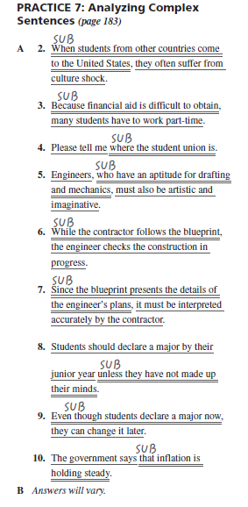

Practice 7A: 1. Adverb clause / 2. Adverb clause / 3. Noun clause / 5. Adjective clause / 6. Adverb clause / 7. Adverb clause / 8. Adverb clause / 9. Adverb clause / 19. Noun clause

Writing Model (Second Draft): 1. When they think of peanuts (Adverb clause) / 2. that the allergy rate will decrease (Noun clause) 4. Although no one knows for certain...(Adverb clause) + why this increase is happening (Noun clause) / 5. that children are becoming more sensitive to allergens (Noun clause) + because cleaning products…till the end (Adverb clause) / 7. that the problem…till the end (Noun clause) 9. Because severe allergies have risen at such an alarming rate (Adverb clause) + that research…until the end (Noun clause) 10. why more and more children… till the end (Noun clause)

Practice 2: 1a. yet, b. but / 2a. yet, b. but / 3a. but, b. yet

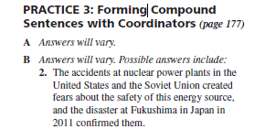

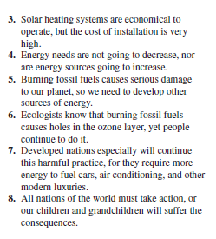

Practice 5: 1. ; after flexibility / 2. ; after jobs / 3. ; after wedding

Compound-complex sentences / p.184: 1. Adverb clause / 2. Adverb clause / 3. two Adverb clauses / 4. two Noun clauses

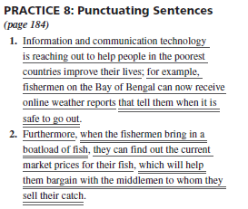

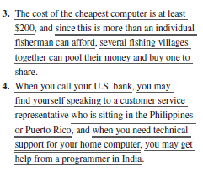

1. Noun clause (that tell…) / 2. Adverb clause (when…) + non-restrictive Adjective clause (which will help them bargain with the middlemen) + restrictive Adjective clause (to whom..) / 3. Adverb clause (since…) / 4. Adverb clause (When…) + restrictive Adjective clause (who is sitting…) + Adverb clause (when you need…)