**Lesson plan – Chapter 11 / Noun clauses**

In week 7, we are finishing up creating interesting, complex sentences.

Remember – what is a complex sentence? A complex sentence contains one independent clause and one (or more) dependent clause(s).

In week 5 and 6, we already discussed two types of dependent clauses (Adjective clause and Adverb clause).

Now we will discuss the 3rd type of dependent clause: **Noun clauses / Chapter 11**

Most of the time, a noun functions as subject or object in a sentence – you know that. (for example: *The answer* was incorrect. (*subject*) – He knew *the answer*. (*object*)

Noun clauses behave like nouns. They function like nouns – they are in subject position or object position.

→ A noun clause is a dependent clause that functions as a noun. A noun clause is often part of an independent clause, where it can be a subject or an object (could be direct object, indirect object, object of preposition). Read the text under Introduction in the textbook p.206. PPP – slide 2

Let’s move to the middle of p.206:

There are three kinds of noun clauses. They begin with different words / subordinators. PPP – slide 3

1. **That clauses** (begin with that)
2. **If / Whether clauses** (begin with whether or if)
3. **Question clauses** (begin with question words, such as who, what, where, when, or how)

Let’s look at examples – I am using the examples from the book:

What the newspaper reported was correct. This is a question clause in subject position.

People once believed that the world was flat. This is a *that* clause in object position.

I do not know if/whether the medication works. This is an *if / whether* clause in object position.

If/Whether the medication works is unknown. This is an *if / whether* clause in subject position.

Notice there is NO COMMA!

NEVER use a comma to separate a noun clause from the independent clause (textbook p. 206 – Punctuating Noun Clauses). This may be new for you – never a comma before that!

On p.207, you find a text (Writing Model): identify the noun clauses in the text – this should not be difficult for you.

Now let’s practice these three kinds of noun clauses in detail.

1. **That clauses**

p. 207, under That Clauses, read the text. Notice that you can omit *that* when the meaning is clear without it.

A that clause can appear in different locations (follow in textbook p.208) PPP – slide 4

* after the independent clause verb (functions as object)
* after certain adjectives (describing emotions)
* after certain nouns (e.g. idea, theory, thought, claim, assertion, statement, belief…)
* at the beginning of the sentence (functions as subject)

Starting with a that clause may sound awkward for you, so put *It* at the beginning and move the noun clause to the end. (p.208)

awkward: That Earth is getting warmer is certain. ---- sometimes effective, more focus

better: It is certain that Earth is getting warmer.

You can also use active voice in these sentences (review active/passive voice p.208/209).

Practice 1A / p.209: do 2-5 as a mental exercise, then Practice 1B

A common use of that clauses occurs in reported/indirect speech. He said that…-- go to textbook p.210.

You covered reported speech in Advanced Grammar. Please review the special rules of verb tenses on your own. PPP – slide 5

Now do Practice 2 on p.211

There is also a special verb tense in so-called subjunctive noun clauses (textbook p.212).

The subjunctive form of a verb is the same as the base form – for example *be, go, come, do*

After certain verbs and adjectives in independent clauses, you must use the subjunctive form of the verb in the noun clause. Look at the verbs and adjectives in the box – they indicate urgency, advisability, necessity, and desirability. PPP – slide 6

Look at the sentences and see the use of the subjunctive form of the verb.

Now do Practice 3 / p.212,213

1. **If/Whether clauses**

What is the difference between *if* and *whether*? *Whether* is more formal (textbook p.214 – read the text and look at the five possible patterns).

Notice that *if/whether* clauses are statements and require a period at the end, not a question mark. Look at the box and see how a question is changed into a sentence with an *if/whether* clause.

Now let’s practice: Practice 4A,B (complete the letter) / p.214,215

1. **Question clauses**

Question clauses begin with subordinators such as who, what, when, where, why, how, how much, how long,… (textbook p. 216)

Again, look closely at the box on p.216 and observe how a question is changed into a question clause.

Let’s do Practice 5A, B (complete the email memo) / p,216,217

All of you have used these noun clauses in your texts. Now you are more aware of the different options, and you are more aware of correct punctuation (NO COMMA).

PPP – slide 7: Here you have more examples of noun clauses. Can you find them in the sentences? What type is it (type 1, 2, or 3)? What is the function of the clause (subject, direct object, indirect object, object of preposition)?

The last exercise I want you to do is to correct a text on p.218 (Editing Practice). We have not done that before. Find nine more errors in the text – look for the kinds of errors presented in the textbook.

How did you do? For next week, I want you to practice writing noun clauses.

!! Assignment = A4 (to be uploaded on moodle on time): Writing practice for noun clauses: textbook p.219 – respond to a job listing – read the text. You do not have to use the ads in the textbook; you can create your own fictional ad. Write 5 sentences (similar to p.215) where you inquire about the ad. You do not have to use a letter format, just list your sentences 1….5. Define which type of noun clause (1, 2, or 3) you used in the sentence.

Answer key:

Writing Model: that the sports starts…/if someone is a role model / whether he or she…/what the morally right…/ who might need their help / where they can find personal gain / how to keep …/ who is truly a good…

Practice 1B: 2. It is undeniable that ocean…/ 3. It has been well documented that burning…4. It has been proven that winters…

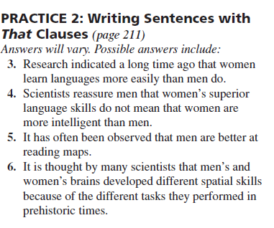

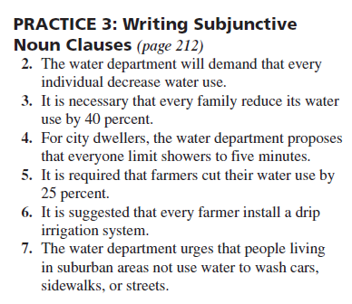

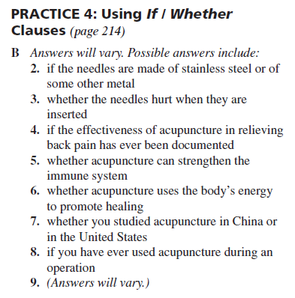

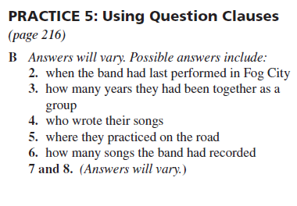

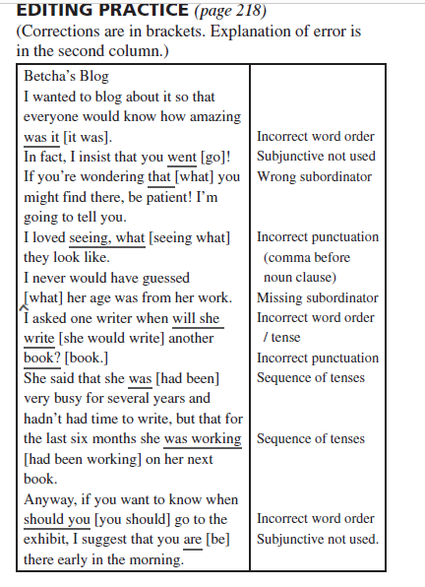

PPP – slide 7: 1. What Alicia said (type 3) – subject / 2. that the directions were wrong (type 1) – direct object / 3. what Alex decided to do (type 3) – object of preposition / 4. if they should buy the house (type 2) – direct object / 5. Whoever thought of that idea (type 3) – subject / 6. whoever interviewed you (type 3) – indirect object / 7. whenever we get hungry (type 3) – object of preposition