**Lesson plan – Chapter 12 / Adverb clauses**

In week 6, we continue to add complexity to your sentences. We are adding complexity by combining independent and dependent clauses to make your sentences longer and more structured. In week 5, we discussed Adjective clauses.

Now we continue with the 2nd type of dependent clause: **Adverb clauses / Chapter 12**

Under Introduction on p. 222 in your textbook it says: An adverb clause is a dependent clause that functions as an adverb. Read on. An adverb clause begins with a subordinator (we know already from last week that dependent clauses begin with subordinators) that expresses the relationship between the adverb clause and the independent clause. There are various kinds of adverb clauses - always showing a different relationship between adverb clause and independent clause (relationship of time, place… – look on p.223) PPP – slide 2,3

Look at the blue box on p.222: Here we have adverb clauses of time (subordinator *as soon as*) and contrast (subordinator *although*). You can clearly see the relationship between the DC and the IC. Whatever relationship it is, you must use the appropriate subordinator. The multifold choice of subordinators adds a nice variety to your sentences/to your texts.

Now analyze the writing model on p.222: read through it and notice the adverb clauses starting with *whenever, everywhere, since, so that, even though*. Underline them in the text. Notice how “compact” these sentences are. You can achieve the same effect in your texts by incorporating adverb clauses. They clearly connect your thoughts/your ideas.

Now look at the use of commas in the writing model. Where do you notice commas?

If you start the sentence with the adverb clause (DC), you have to put a comma.

Rule 1: DC , IC

If you start the sentence with the independent clause (IC), you do not put a comma.

Rule 2: IC DC (no comma!)

Read the text under *Punctuation of Adverb clauses* on p.223. PPP – slide 4

Do not worry about the exception in slide 4 at this point; we will get to that.

The textbook introduces now the appropriate subordinators for the various kinds of adverb clauses and provides clear examples. Please do not be overwhelmed by the quantity of subordinators presented in the following pages – see it as a great option for you to make your texts more coherent and to clearly show the connection between your ideas/points.

Let’s go through them. There is a slide for each adverb clause in your PPP (slide 5 – 13).

Time clauses: p.224

Read the text and look at the blue box: You know all these subordinators, look at the meaning, read through the examples, look at the commas.

Now do Practice 1

Try it out – p.225 (mental exercise)

Place clauses: p.225

Read the text and look at the blue box. You know these subordinators, look at the meaning, read through the examples, look at the commas.

Now do Practice 2

Distance, frequency, and manner clauses: p.226

Read the text and look at the blue box. You know all these subordinators, look at the meaning, read through the examples. Notice there are no commas because most manner clauses follow the IC.

Read the text under *Notes* to understand the difference between formal and informal English.

Now do Practice 3 (answers may vary)

Reason clauses: p.228

Read the text and look at the blue box. You know these subordinators, look at the meaning, read through the examples, look at the commas.

Now do Practice 4A / 4B is a mental exercise

Result clauses: p.230

Read the text and look at the blue box. You know all these subordinators, look at the meaning, read through the examples. Notice there are no commas because result clauses follow the IC.

Now do Practice 5A

Purpose clauses: p.233

Read the text and look at the blue box. You know these subordinators, look at the meaning, read through the examples, look at the commas. Also read the text under *Notes*.

Now do Practice 6A and 6B

Contrast clauses: p.235, 236

1. Direct opposition clauses

Read the text and look at the blue box. *While* and *whereas* have the same meaning and are interchangeable. What do you notice when you read the examples? Yes, there is a comma before the subordinator *whereas,* which is the exception to the punctuation rule.

IC DC (no comma!) This is the usual rule. Read the text under *Notes*. IC , DC comma in direct opposition clauses – while / whereas

1. Concession (Unexpected Result) clauses

Read the text and look at the blue box. Also read the text under *Notes* because it points out the difference between *although*, *even though*, and *though*.

Now you are ready for Practice 7A / pick 2 numbers of 7B

Conditional clauses: p.239

This is nothing new for you – you did this in Advanced Grammar.

Study the blue boxes / see it as a revision.

Yeah!! We did it!! I know this was hard work, but it is essential for good writing to vary your sentence structures.

PPP – slide 14: review

!! Now you are prepared to do the chapter quiz on moodle: Chapter 12 Test

Answer key

Practice 1: possible answers: 2. when, as soon as / 3. while / 4. until / 5. As soon as, When / 6. After

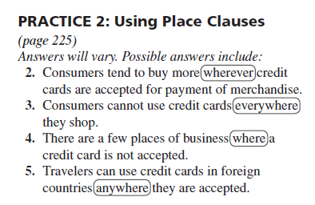

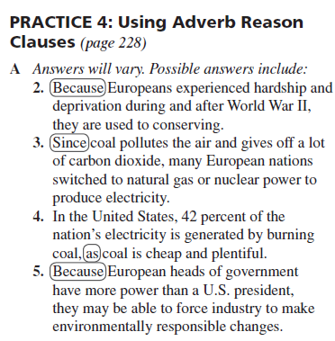

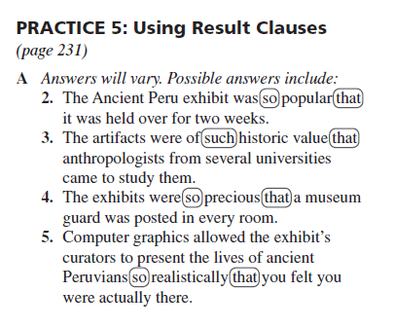

6. There were so few exhibits that we were able to see all of them in an hour.

